Use case diagram for Book Store Management System

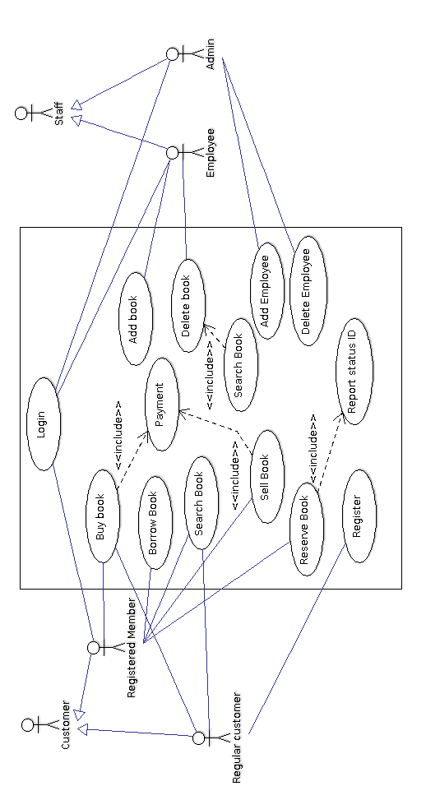

|  |  |
| --- | --- |
| List of actors | |
| Actor | Description |
| Employee | Manages the books inventory. |
| Admin | Has absolute control over the software. Oversees the functioning of all the services of the system. |
| Regular customer | Can search for a book or buy a book. He can also register himself. |
| Registered member | Can do all the functions of a regular customer along with borrowing, selling and reserving a book when it is not available. |

|  |  |  |
| --- | --- | --- |
| List of use cases | | |
| # | Use Case | Description |
| UC1 | Login | Allows user to login to the system by authenticating the credentials of the user |
| UC2 | Buy book | Allows a customer to buy a book. |
| UC3 | Borrow book | Allows a registered customer to borrow a book. |
| UC4 | Search book | Allows customers/ employees to search for a book |
| UC5 | Sell book | Allows a registered customer to sell a book. |
| UC6 | Reserve book | Allows a registered customer to reserve a book. |
| UC7 | Report status id | Keeps a track of which customer has reserved the book |
| UC8 | Register | Allows a regular customer to register |
| UC9 | Add book | Allows an employee to add a new book to the inventory |
| UC10 | Delete book | Allows an employee to delete book from the inventory |
| UC11 | Add employee | Allows the admin to add new employees |
| UC12 | Delete employee | Allows the admin to remove employees |
| UC13 | Payment | Module that handles transactions and generates a bill. |

|  |  |  |
| --- | --- | --- |
| Mapping functional requirements to use cases | | |
| FR# | FR Description | Use case(s) |
| R1 | Member registration | UC8 |
| R2 | User login | UC1 |
| R3 | Buy a book | UC2 |
| R4 | Sell a book | UC5 |
| R5 | Rent a book | UC3 |
| R6 | Search for a book | UC4 |
| R7 | Get resale price | UC5 |

UC1 - Login

|  |  |
| --- | --- |
| Use Case | UC1 - Login |
| Description | Allows a member to login to the system using his username and password |
| Assumptions |  |
| Actors | * Admin * Employee * Registered customer |
| Steps | 1. User types in username 2. User types in password 3. User clicks on login button 4. IF successful then show respective home page   ELSE display error |
| Variations |  |
| Non-functional |  |
| Issues |  |

UC2 – Buy book

|  |  |
| --- | --- |
| Use Case | UC2 – Buy book |
| Description | Allows a customer to buy a book. |
| Assumptions | The book should be available. |
| Actors | * Customer |
| Steps | 1. Choose the desired book  2. Proceed to payment |
| Variations |  |
| Non-functional |  |
| Issues |  |

UC3 - Borrow book

|  |  |
| --- | --- |
| Use Case | UC3 - Borrow book |
| Description | Allows a registered customer to borrow a book. |
| Assumptions | * The customer should be a registered member. * The book should be available. * The customer shouldn’t have already borrowed two books. |
| Actors | * Registered customer |
| Steps |  |
| Variations |  |
| Non-functional |  |
| Issues |  |

UC4 – Search book

|  |  |
| --- | --- |
| Use Case | UC4 – Search book |
| Description | Allows customers/ employees to search for a book |
| Assumptions |  |
| Actors | * Customers * Employees |
| Steps | 1. Accept keywords 2. Search the database 3. Display results |
| Variations |  |
| Non-functional |  |
| Issues |  |

UC5 – Sell book

|  |  |
| --- | --- |
| Use Case | UC5 – Sell book |
| Description | Allows a registered customer to sell a book. |
| Assumptions | The book should be in a state where it can be sold. |
| Actors | * Registered customer * Employee |
| Steps | * 1. The customer must first get the book to be sold at the book store.   2. The customer will open the ‘Sell Book’ panel and enter details.   3. The system will display a price at which the store will purchase the book. |
| Variations |  |
| Non-functional |  |
| Issues |  |

UC6 – Reserve book

|  |  |
| --- | --- |
| Use Case | UC6 – Reserve book |
| Description | Allows a registered customer to reserve a book. |
| Assumptions | * The book is currently not available |
| Actors | * Registered customer * Employee |
| Steps |  |
| Variations |  |
| Non-functional |  |
| Issues |  |

UC7 - Report status id

|  |  |
| --- | --- |
| Use Case | UC7 - Report status id |
| Description | Keeps a track of which customer has reserved the book. |
| Assumptions |  |
| Actors | * Registered customer * Employee |
| Steps |  |
| Variations |  |
| Non-functional |  |
| Issues |  |

UC8 - Register

|  |  |
| --- | --- |
| Use Case | UC8 - Register |
| Description | Allows a regular customer to register. |
| Assumptions |  |
| Actors | * Regular customer * Employee |
| Steps |  |
| Variations |  |
| Non-functional |  |
| Issues |  |

UC9 – Add book

|  |  |
| --- | --- |
| Use Case | UC9 – Add book |
| Description | Allows an employee to add a new book to the inventory. |
| Assumptions |  |
| Actors | Employee |
| Steps | * 1. Open the add books panel.   2. Enter the details of the book.   3. Click on SAVE option to save it to the database. |
| Variations |  |
| Non-functional |  |
| Issues |  |

UC10 – Delete book

|  |  |
| --- | --- |
| Use Case | UC10 – Delete book |
| Description | Allows an employee to delete book from the inventory. |
| Assumptions |  |
| Actors | Employee |
| Steps | * + 1. Search for the book to be deleted     2. Verify that you’re deleting the right book     3. Click DELETE to delete the book |
| Variations |  |
| Non-functional |  |
| Issues |  |

UC11 – Add employee

|  |  |
| --- | --- |
| Use Case | UC11 – Add employee |
| Description | Allows the admin to add new employees. |
| Assumptions |  |
| Actors | Administrator |
| Steps | * + - 1. Open the add employee panel.       2. Enter details of the new employee.       3. Click on SAVE option to save it to the database. |
| Variations |  |
| Non-functional |  |
| Issues |  |

UC12 – Delete employee

|  |  |
| --- | --- |
| Use Case | UC12 – Delete employee |
| Description | Allows the admin to remove employees. |
| Assumptions |  |
| Actors | Administrator |
| Steps |  |
| Variations |  |
| Non-functional |  |
| Issues |  |

UC13 - Payment

|  |  |
| --- | --- |
| Use Case | UC13 - Payment |
| Description | Module that handles transactions and generates a bill. |
| Assumptions |  |
| Actors |  |
| Steps |  |
| Variations |  |
| Non-functional |  |
| Issues |  |